

NAME: EXCELLENCE NG’ENDO
ADM NO: BSCCS/2024/53679

COURSE: BACHELOR OF SCIENCE IN COMPUTER SCIENCE
DEPARTMENT: COMPUTING AND INFORMATICS.
UNIT NAME: ADVANCED WEB DESIGN AND DEVELOPMENT
UNIT CODE:BIT3208
Lecturer Name- MICHAEL NYORO
Academic Year -3.2
Project Title: Decorum Bookshop Inventory System
Selected Technologies - PHP + MYSQL

GitHub Link: https://github.com/ExcellenceCreates05/BIT3208-Advanced-Web-Design-and-Developmet.-BSCCS-2024-53679

Table of Contents
TABLE OF FIGURES 11
Week 1: Local Environment Setup 12
Installation and Testing of Local Development Environment 12
Week 2: Wireframes and GUI Design 15
Title: User Interface Planning and System Design 15
Fig 2: Dashboard Layout Design 15
Week 3: JavaScript and PHP Basics 18
Title:Frontend Interaction and Backend Foundation 18
Week 4 Lesson: Server-Side Components and Backend Development Foundations 22
WEEK 5 26
TOPIC: Database Components and CRUD Operations 26
WEEK 6 31
Database Integration and CRUD Operations 31
REFLECTION 34
WEEK 7 35
User Authentication and Session Management 35
38
REFLECTION 40
WEEK 8 41
Responsive Web Design and Mobile-First Development 41
41
REFLECTION 44

TABLE OF FIGURES
Figure 0-1:Installation of XAMPP 5
Figure 0-2: Apache and MySQL Running 6
Figure 0-1:Localhost Test Page 6
Figure 0-2: Hello World Test 7
Figure 0-3: Database Connection Test 7
Figure 0-4: Error experienced during connection test. 7
pFigure 0-5:PHP script for creating decorum_bookshop 8
Figure 0-1: Admin Product View 9
Figure 0-2:Admin Dashboard 9
Figure 0-3:Users Order View 10
Figure 0-4:Login Page Design process 10
Figure 0-5:Login Page Figma Design 11
Figure 0-1:JavaScript Form Validation 12
Figure 0-2:Email & Password validation. 13
Figure 0-3:Password checker code 13
Figure 0-4:Successful login 14
Figure 0-5:Successful Database Connection 14
Figure 0-6: Successful login Into Decorum Bookshop 14
Figure 0-7: Hidden Sidebar 15
Figure 0-1:Server-Side authentication Handling 16
Figure 0-2:Account Bloced after 5 failed attempts 16
Figure 0-3RBAC- Administrator Dashboard 17
Figure 0-4: The Managers view. 17
Figure 0-5: Backened Database schema- Users Table 18
Figure 0-6: Backend Folder Structure 18
Figure 0-7: Dtabase Connection Script 19
Figure 0-1:GitHub repository 20
Figure 0-2:SQL Script CREATE Books Table and Insert sample book records 20
Figure 0-3: Books Table with Sample book records 21
Figure 0-4: decorum_bookshop databse structure 21
Figure 0-5: Week 5 File structure 22
Figure 0-6:PDO Queries to fetch Order Mnagement Informtion from Database for the Top Cards 22
Figure 0-7; Top Cards 22
Figure 0-8:Edit Book records Form 23
Figure 0-9: edit_product.php script lines that fetches the Book record to fill the edit Form. 23
Figure 0-10: edit_record.php ; UPDATE records prepared statements. 24
Figure 0-11; Flash message showing Successful Update 24
Figure 0-1:Database Connection Script 25
Figure 0-2: Connection script file inclusion 25
Figure 0-3: AddNew Book Form 26
Figure 0-4;AddBook FormPHP script(add_product.php) 26
Figure 0-5; Error Message when a saved ISBN(Book unique identifier) is enetered 27
Figure 0-6: New Book Record added(Happy Ever After), after using an usaved ISBN 27
Figure 0-7:Delete Button flash message 27
Figure 0-8;Deleted record(Four Figure Mathematical Tables) 27
Figure 0-9:Delete_product script 28
Figure 0-10; delete book prepared statements 28
Figure 0-1:Admin Role View(Role Based Login) 29
Figure 0-2; Manager role view 29
Figure 0-3:Script that directs user to dashboard or index according to Role 30
Figure 0-1:add new users form 30
Figure 0-2;Secure User Registration Module. In this B2B architecture, public registration is disabled; users are securely provisioned by the Administrator to ensure system integrity. 30
Figure 0-1: Cryptographic Password Hashing. Proof of PHP's native password_hash() implementation. Passwords are never stored in plain text, mitigating the risk of database breaches. 31
Figure 0-2; register_user_form.php file - script of the password_hash implementation 31
Figure 0-3; requireLogin('')Restricts acces of register_users_form.php to only Admins 31
Figure 0-1:The Header (Cache-Control), is HTTP that instructs the browser not to Cache the page. To always validate the page, every time a user log in 32
Figure 0-2;Backend logic demonstrating the initialization of secure session variables upon successful cryptographic password verification. 32
Figure 0-3;Session Management and Route Protection. Unauthenticated users attempting to bypass the login screen are intercepted by auth_guard.php and redirected, proving active session validation. 33
Figure 0-4:auth_guard.php- Session Management and Routing 33
Figure 0-5:auth_guard.php - Destroy session and log out user script when logout button is clicked 34
Figure 0-6: Acess to index.php denied with an Admin Role session without going through login page.Script in Figre0-4, (//logged in, wrong Role ) 34
Figure 0-1:Book Stacked in Mobile view instead of table 35
Figure 0-2; Product catalog web view 35
Figure 0-3; Hidden Sidebar(Users Mobile View) 36
Figure 0-4; Exposed sidebar, System Users Mobile View 36
Figure 0-5: System User Webpage view 37
Figure 0-6; Sidebar toggle js script 37
Figure 0-7; CSS Stylingthat makes a table act lie a stand alone block 38
Figure 0-8: CSS Media Query that wraps tables in a horizontally scrollable container 38

Week 1: Local Environment Setup

Installation and Testing of Local Development Environment
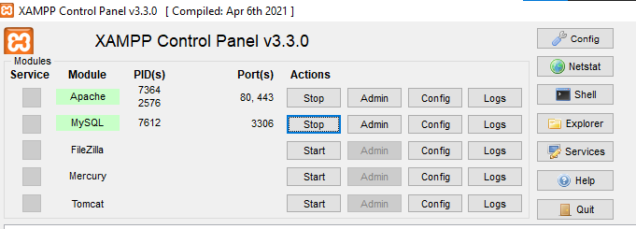
Figure 0-1:Installation of XAMPP

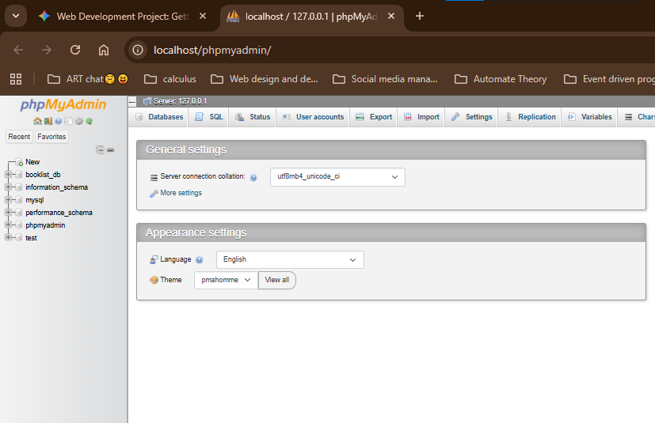
Figure 0-2: Apache and MySQL Running

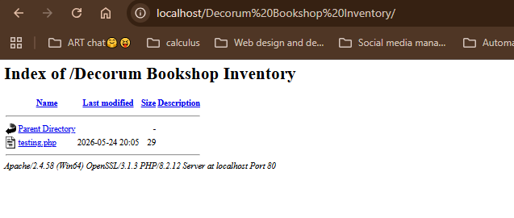
Figure 0-1:Localhost Test Page
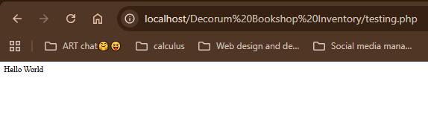
Figure 0-2: Hello World Test

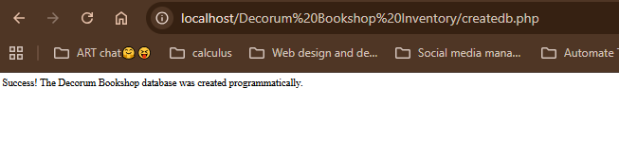
Figure 0-3: Database Connection Test

Error experienced during connection test. The webpage is not connected to the database. The PDO point sout the exact cause of the error.
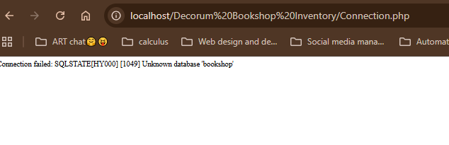
Figure 0-4: Error experienced during connection test.

REFLECTION
Fig 0-2 shows the MySQL can run on the computer as the local host. Fig 0-4 shows connection of the database to PHP sing PDO(PHP for Data Objects). PDO allows change of databases with minimal code change, meaning I can change to PostgresSQL or any other easily as compared to using mysqli-connect. This is more rigid as it serves MySQL and change would require changing the entire code. Using
$conn->setAttribute(PDO::ATTR_ERRMODE, PDO::ERRMODE_EXCEPTION);
prompts PDO to point out the exact case of error if the try block fails as seen in Fig 0-4
I’ve also learnt that a database can be created via PHP (Code below). The output is as seen in Fg0-3s
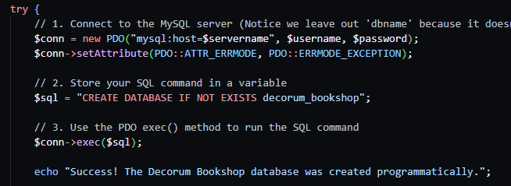
pFigure 0-5:PHP script for creating decorum_bookshop

Week 2: Wireframes and GUI Design

Title: User Interface Planning and System Design
- Hand-drawn Wireframe
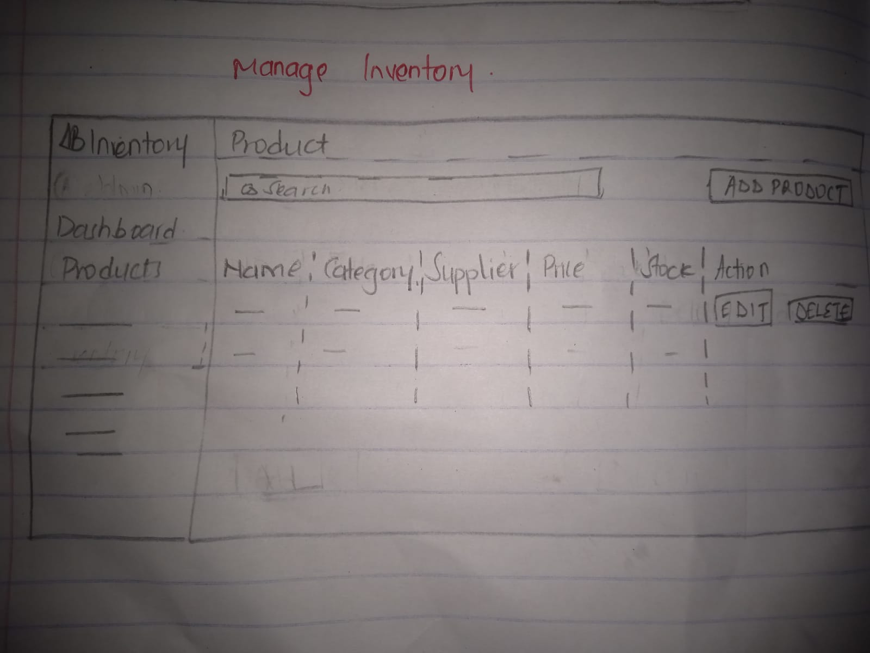
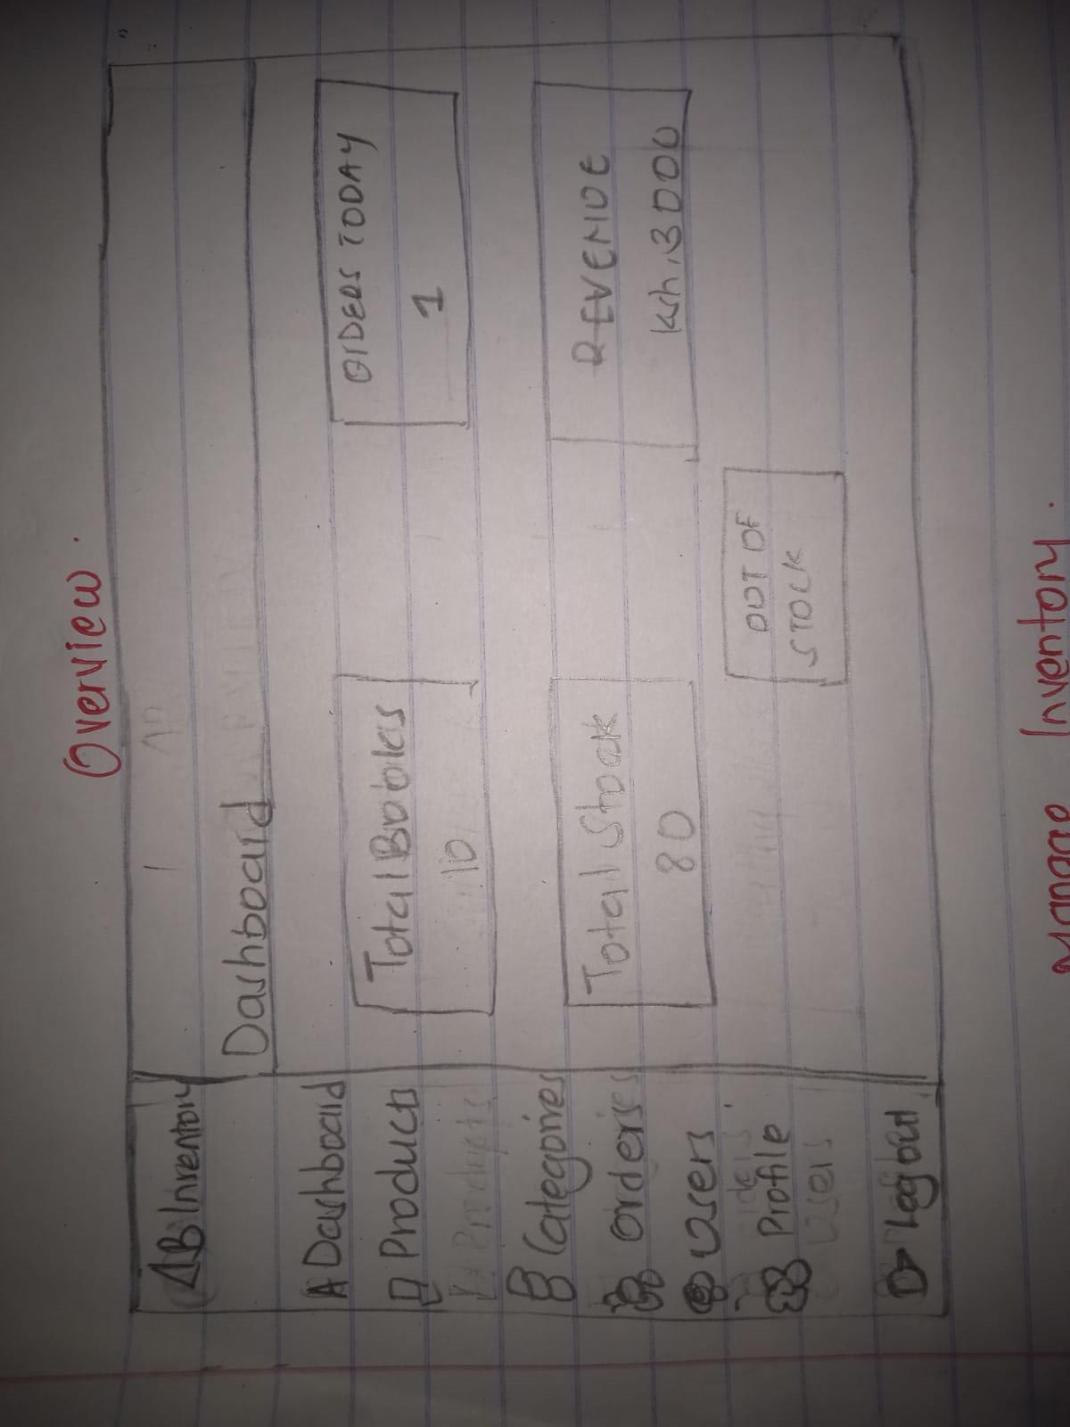Figure 0-1: Admin Product View
Admin Dashboard

Fig 2: Dashboard Layout Design
Figure 0-2:Admin Dashboard

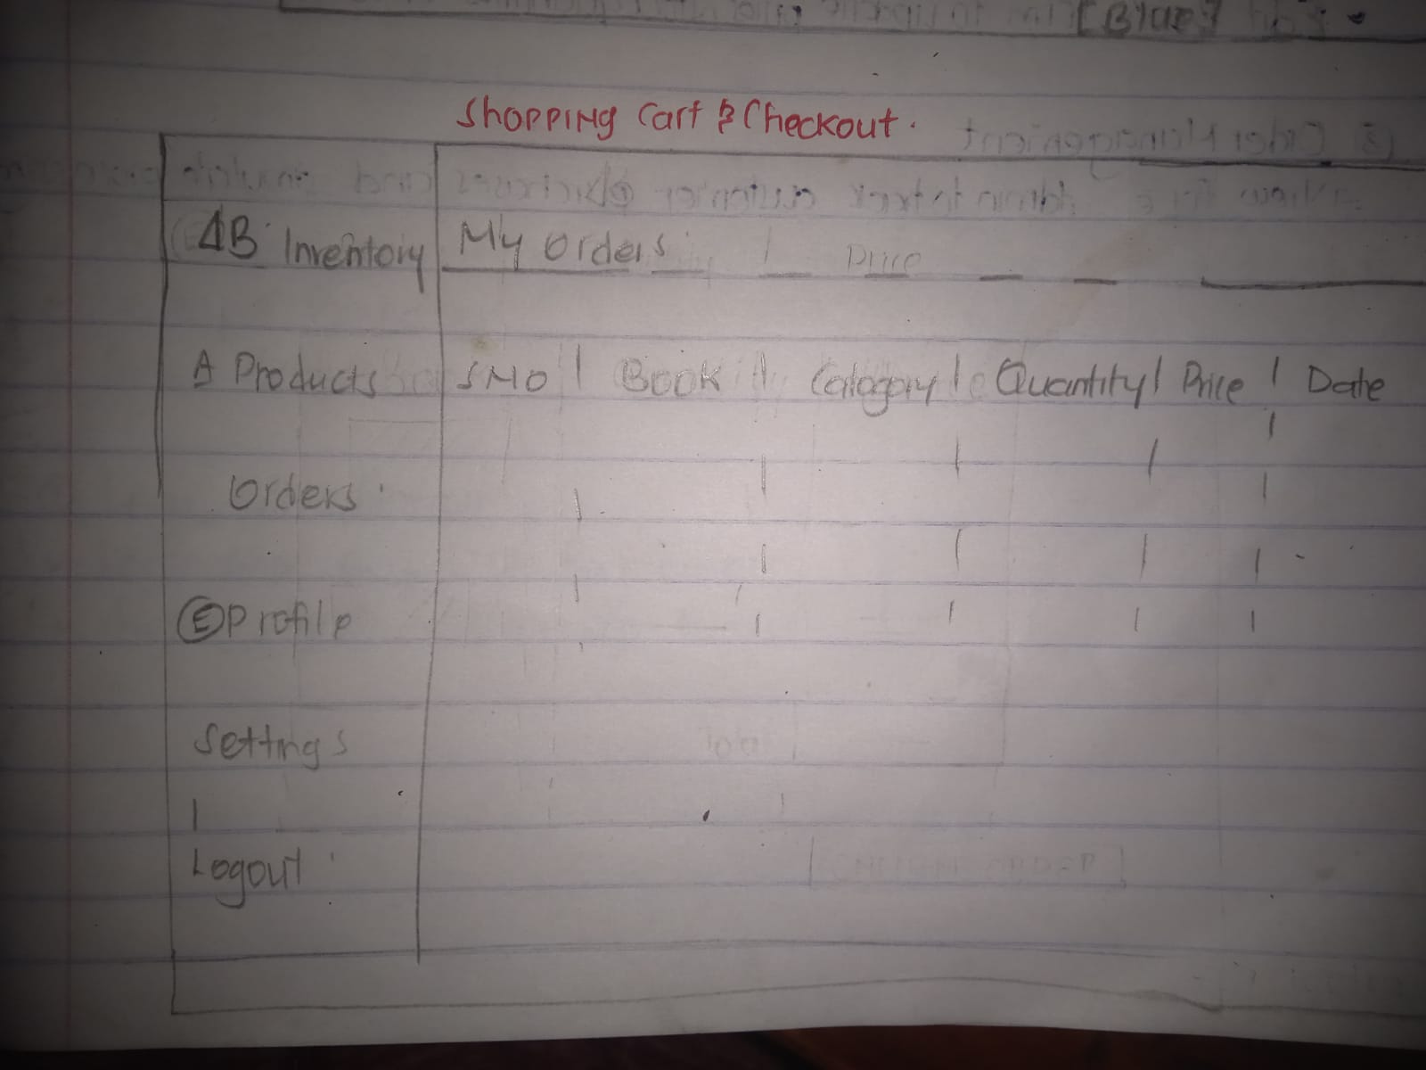
Figure 0-3:Users Order View
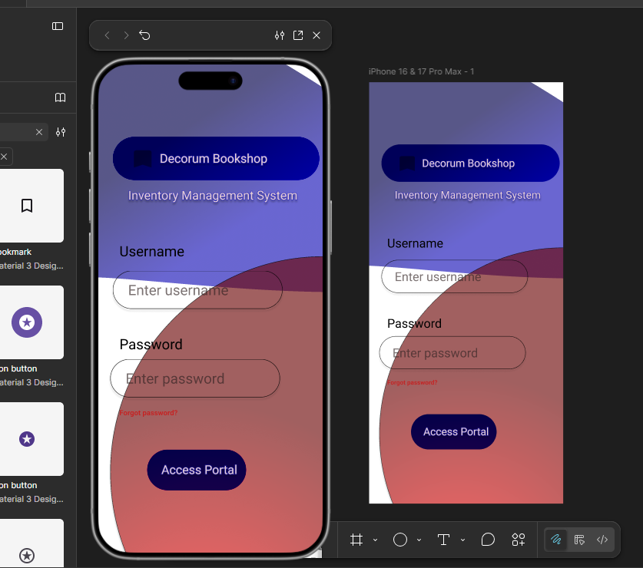
Figure 0-4:Login Page Design process
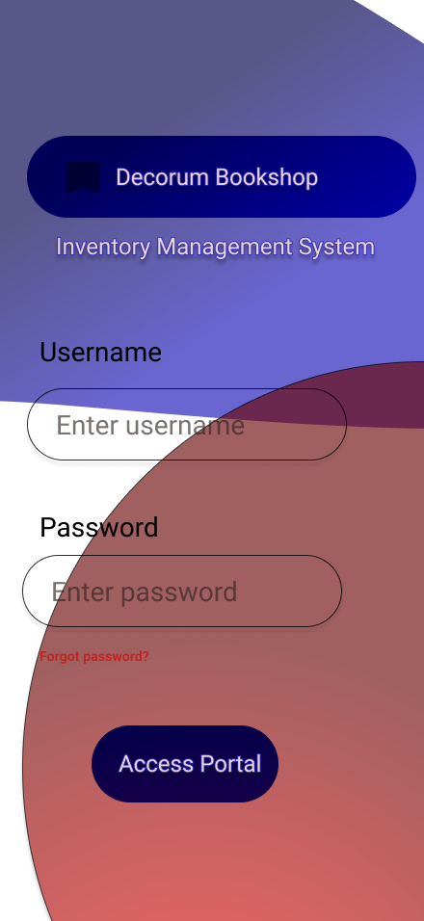
Figure 0-5:Login Page Figma Design
- COLOR THEME
- Red
- Blue
- White
- PROJECT THEME
Inventory System – Decorum Bookshop Inventory System.
Allows Admin manager to keep track of the books and records. The admin admits and tracks users within the system.
It is a Buyer to Buyer system (B2B)

REFLECTION
Creating the UI/UX components was challenging. I was able to hand draw but was challenged using Figma . Used a sidebar on the left because it is easy to hide and provide a simple, easy too. Use of Red, Blue and White color for their simplicity and easy communication. The dashboard itself remains static as content on it changes depending who has logged in(Admin/Manager). I’ve experienced multiple errors while translating the Figma design to code,currently working with a mockup.

Week 3: JavaScript and PHP Basics

Title:Frontend Interaction and Backend Foundation

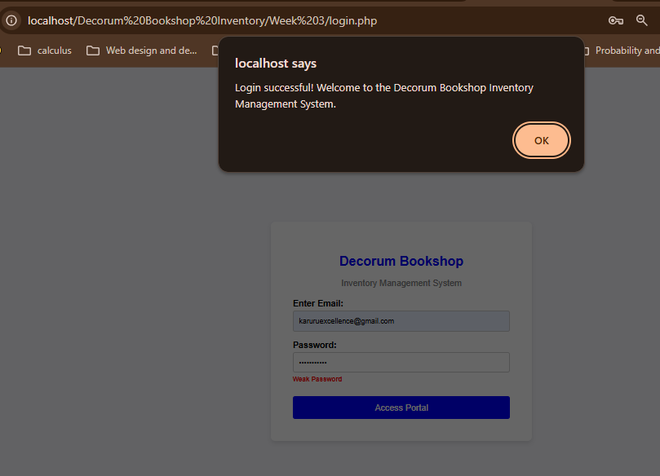
Figure 0-1:JavaScript Form Validation
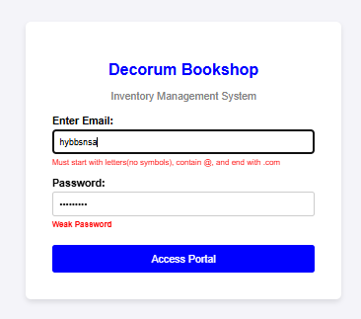

Figure 0-2:Email & Password validation.
Email Validation. Invalid email evokes an error message that prompts the user to enter the correct email format.

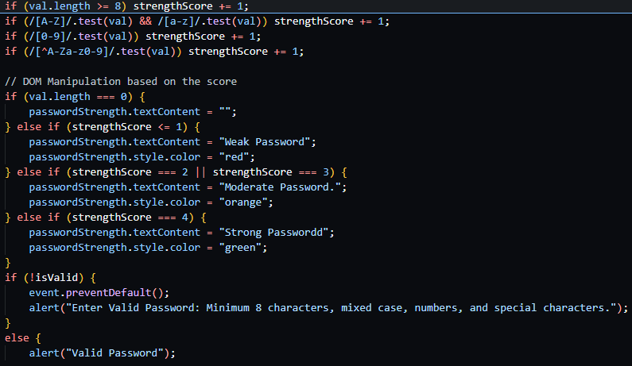
Figure 0-3:Password checker code

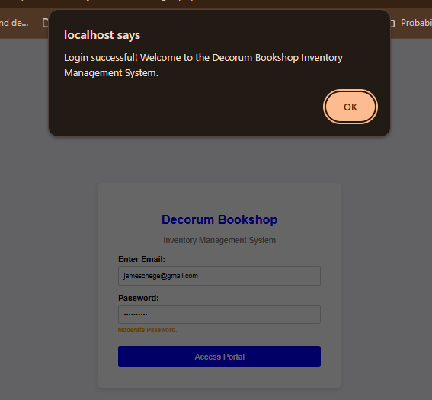
Figure 0-4:Successful login

Once user enters a Valid email & Password, they receive a SUCCESSFUL LOGIN message.
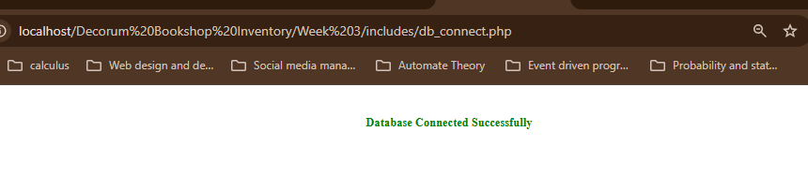
Figure 0-5:Successful Database Connection


Figure 0-6: Successful login Into Decorum Bookshop
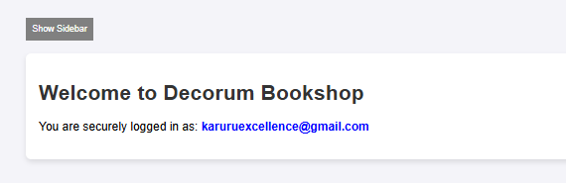
Figure 0-7: Hidden Sidebar
Document Object Model (DOM) is Achieved via Interactive Show/Hide Sidebar Button. It either Hides the sidebar when clicked and vice versa.

REFLECTION
Used PDO PHP with javascript and HTML. Implemented Password & Email validation using Java script. Learnt about Document Object Model and how to implement it. The Show/Hide SideBar Button changes the content of the page dynamically. Pushed the entire week 3 on Github for version Control and tracking changes.Encountered a few issues while committing Week 3 work but it was resolved. Commiting changes on

Week 4 Lesson: Server-Side Components and Backend Development Foundations

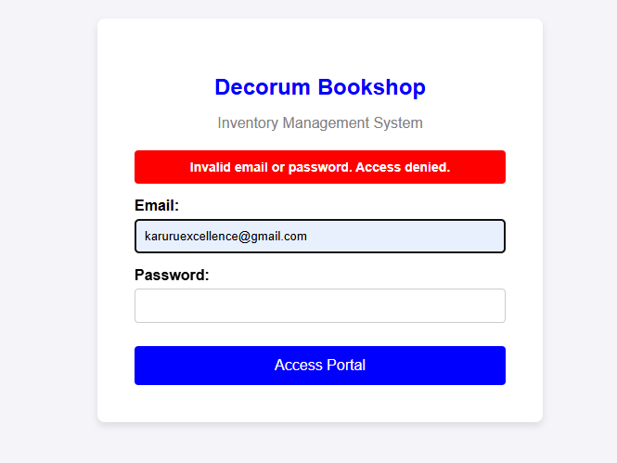
Figure 0-1:Server-Side authentication Handling
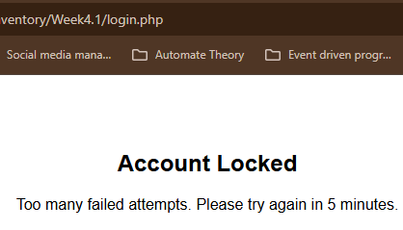
Figure 0-2:Account Bloced after 5 failed attempts
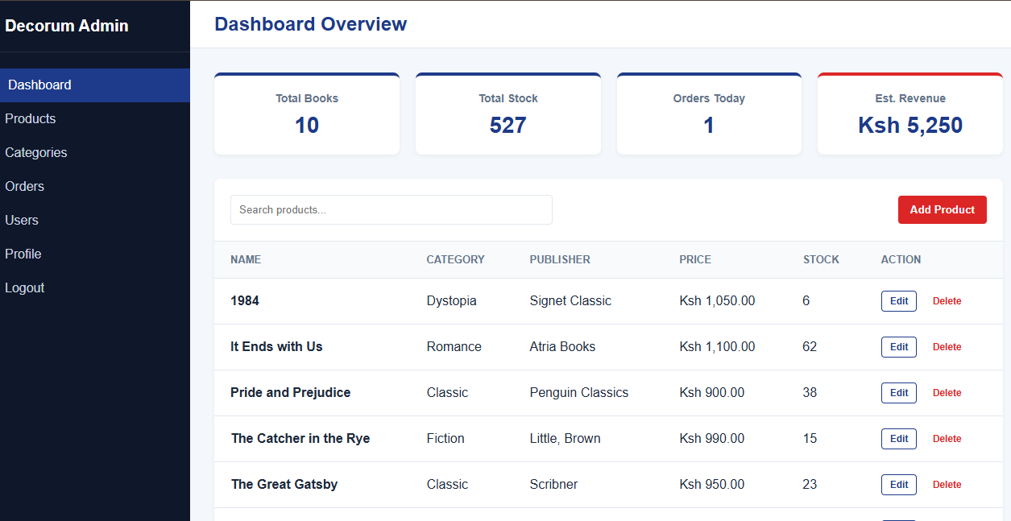
Figure 0-3RBAC- Administrator Dashboard
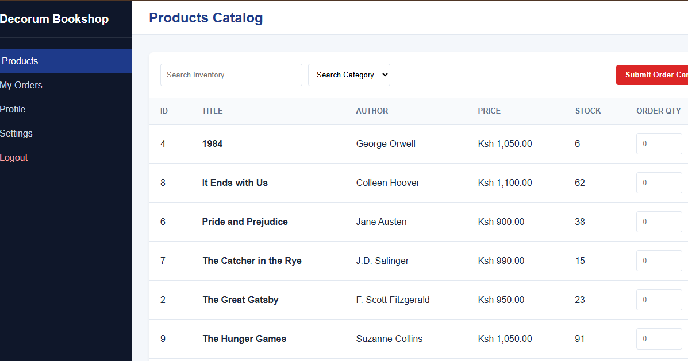
Figure 0-4: The Managers view.

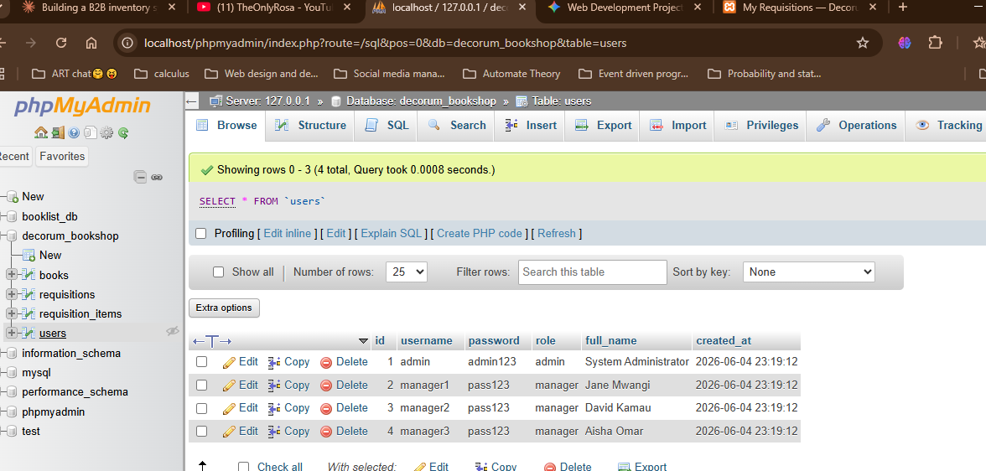
Figure 0-5: Backened Database schema- Users Table
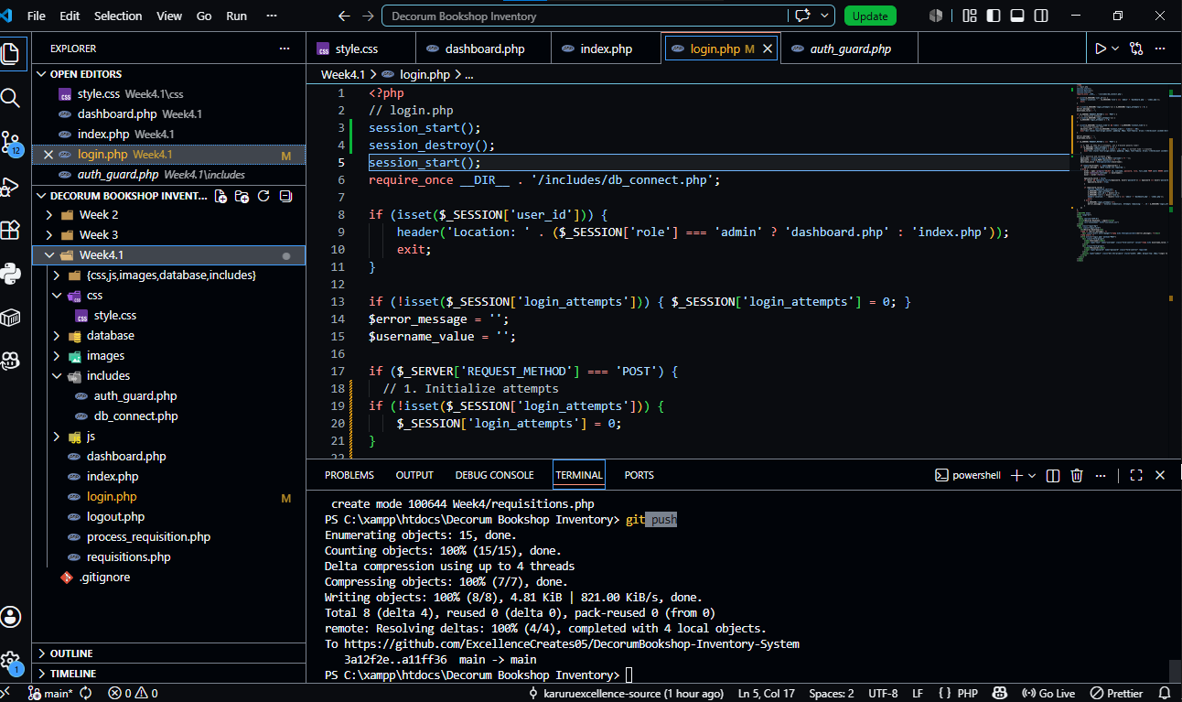
Figure 0-6: Backend Folder Structure

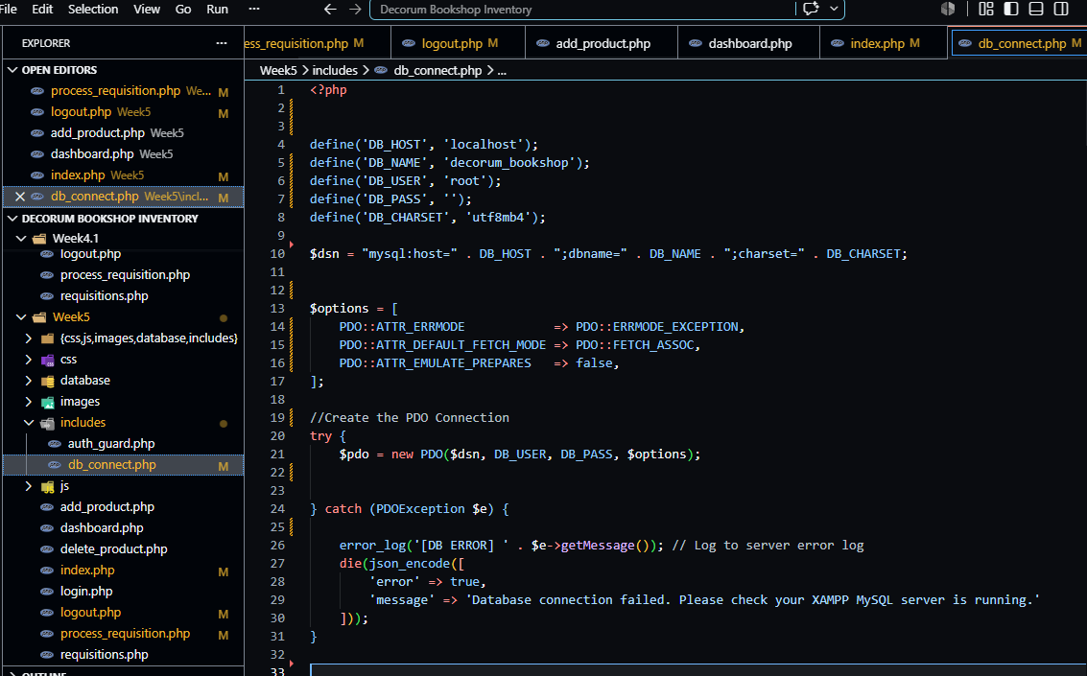
Figure 0-7: Dtabase Connection Script

REFLECTION

In this week I gained more knowledge on PHP for Data Objects centered Queries and code. It made it easy to work with clean prepared statements, making the platform more secure with less effort . I’ve learnt that it is Database agnostic , yet to prove but may test the feature in the future. Worked with a try-catch block in db_connect.php to connect to the database. It is well suited to handle exceptions that If…Else statement.

WEEK 5

TOPIC: Database Components and CRUD Operations

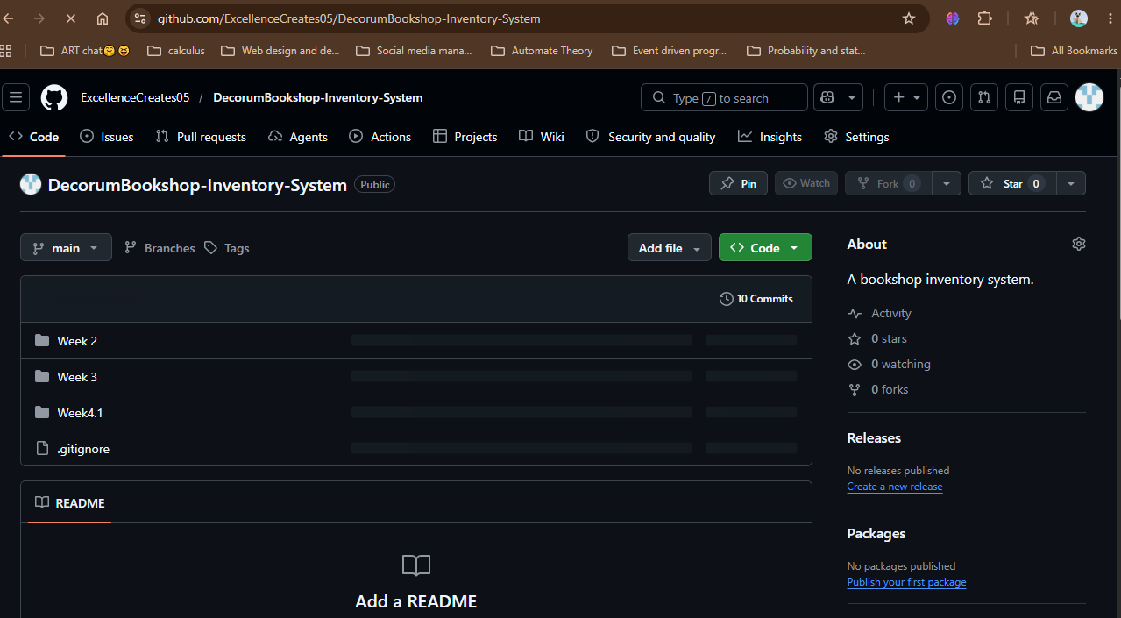
Figure 0-1:GitHub repository

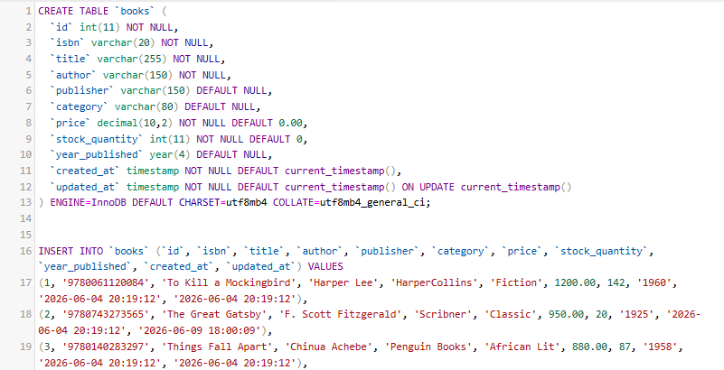
Figure 0-2:SQL Script CREATE Books Table and Insert sample book records
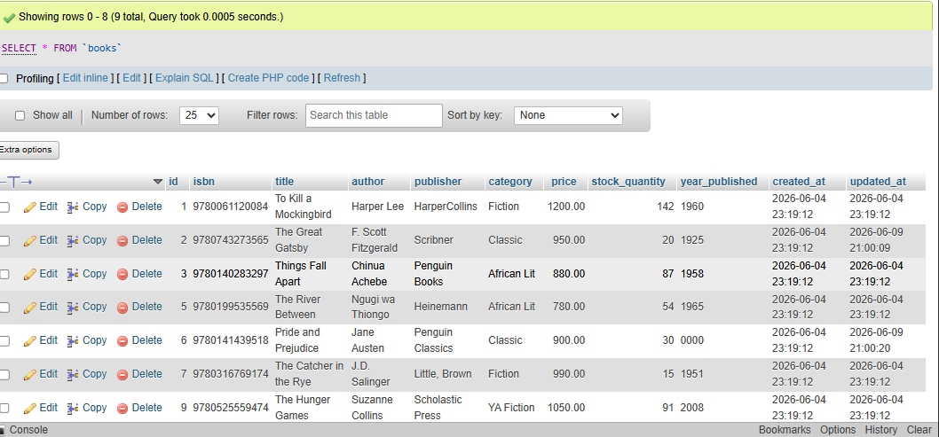
Figure 0-3: Books Table with Sample book records

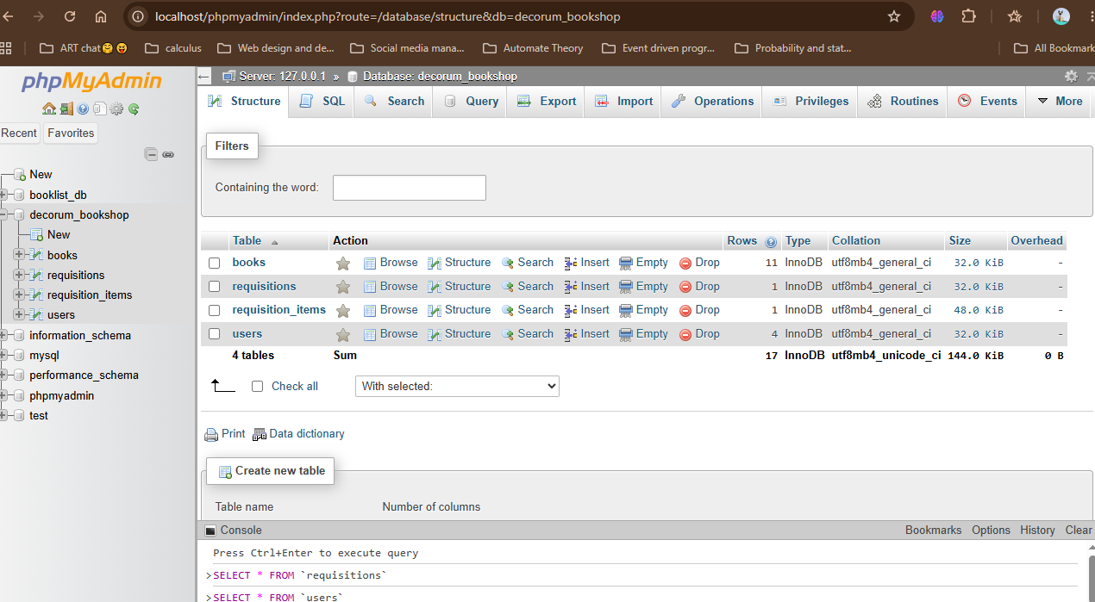
Figure 0-4: decorum_bookshop databse structure

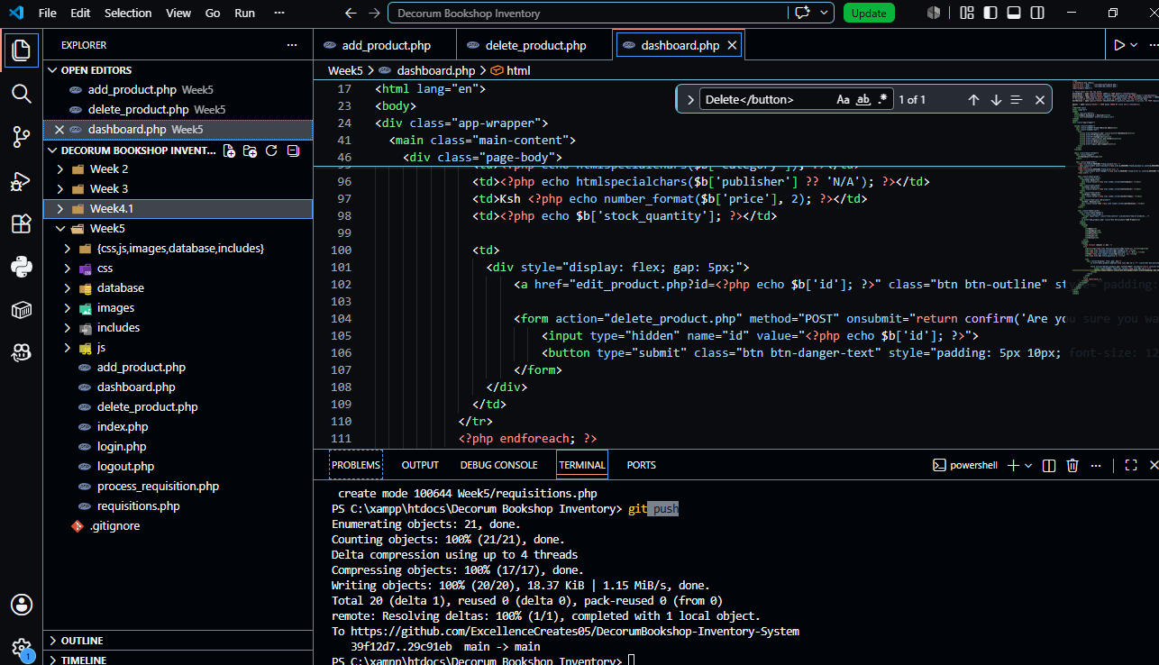
Figure 0-5: Week 5 File structure
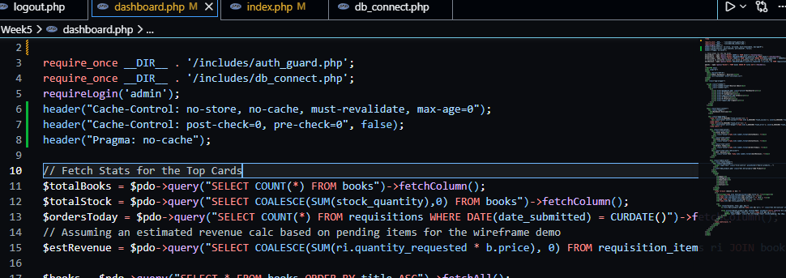
Figure 0-6:PDO Queries to fetch Order Mnagement Informtion from Database for the Top Cards

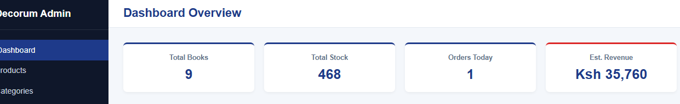
Figure 0-7; Top Cards
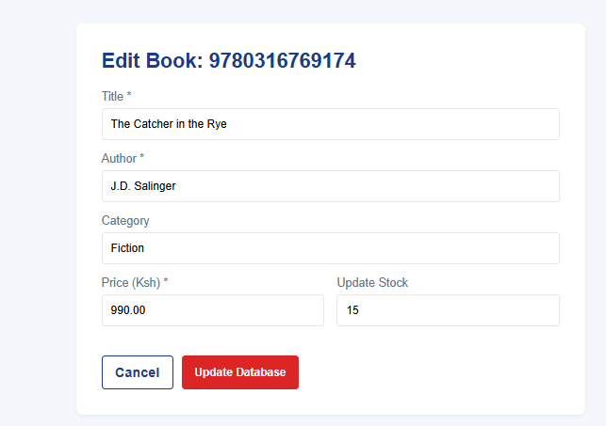
Figure 0-8:Edit Book records Form

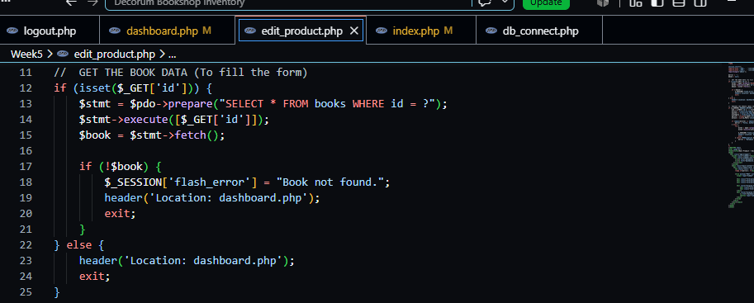
Figure 0-9: edit_product.php script lines that fetches the Book record to fill the edit Form.
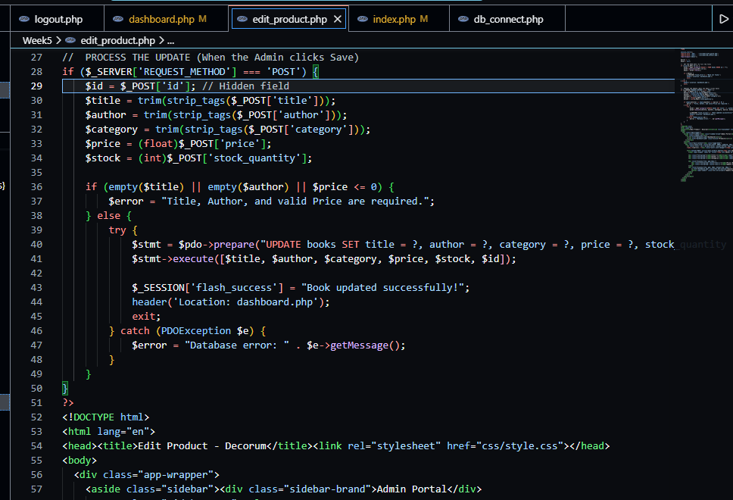
Figure 0-10: edit_record.php ; UPDATE records prepared statements.
Figure 0-11; Flash message showing Successful Update

REFLECTION
Fig 0_7 shows the prepared statement (line 13-15) that selects the records from the database reflects them in the Edit Form . The UPDATE Books..prepared statement(line40-49) send the updated records back to the database and ensures it reflects in the Product List

WEEK 6

Database Integration and CRUD Operations

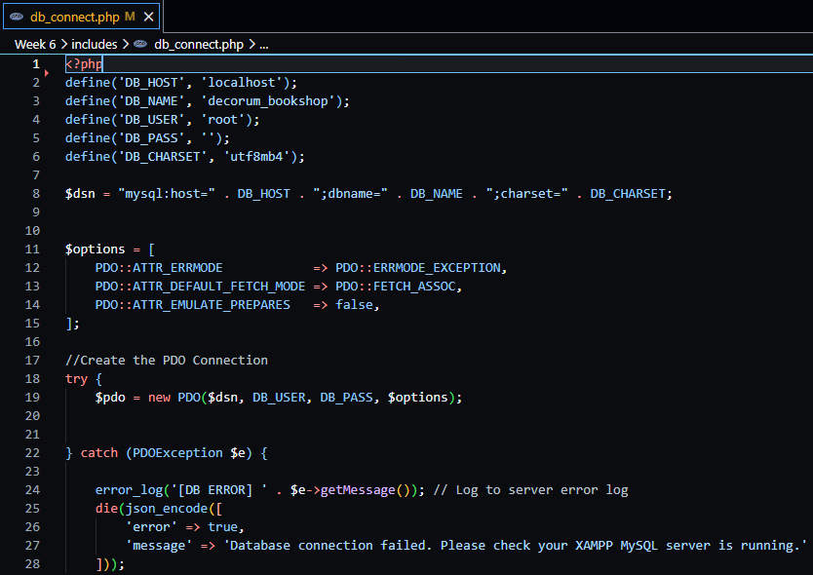
Figure 0-1:Database Connection Script

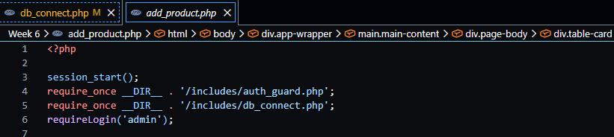
Figure 0-2: Connection script file inclusion
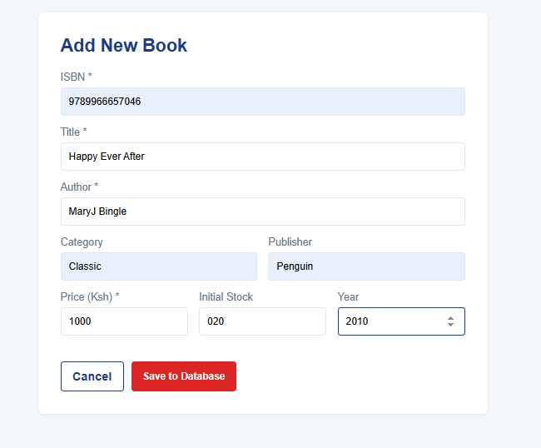
Figure 0-3: AddNew Book Form
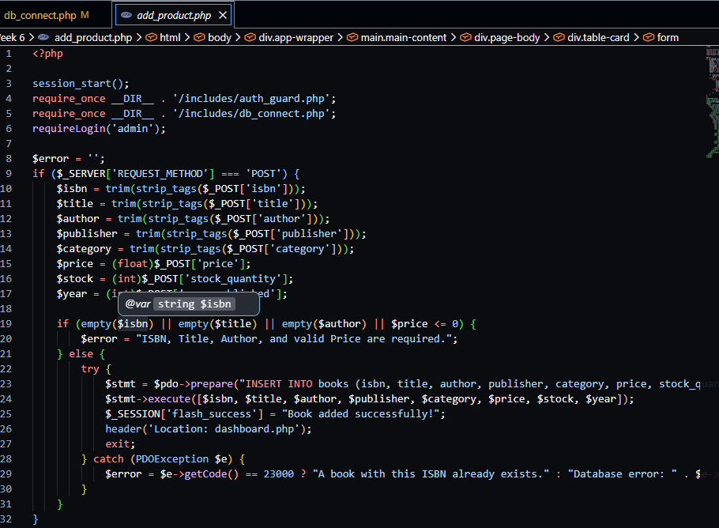
Figure 0-4;AddBook FormPHP script(add_product.php)
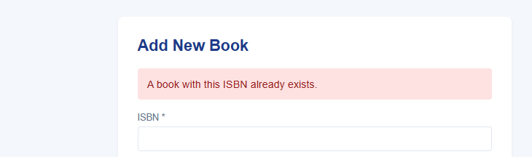
Figure 0-5; Error Message when a saved ISBN(Book unique identifier) is enetered
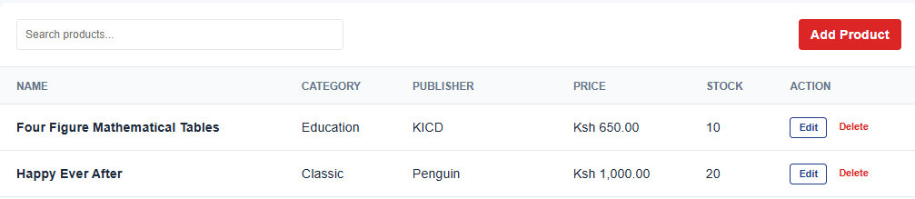Figure 0-6: New Book Record added(Happy Ever After), after using an usaved ISBN
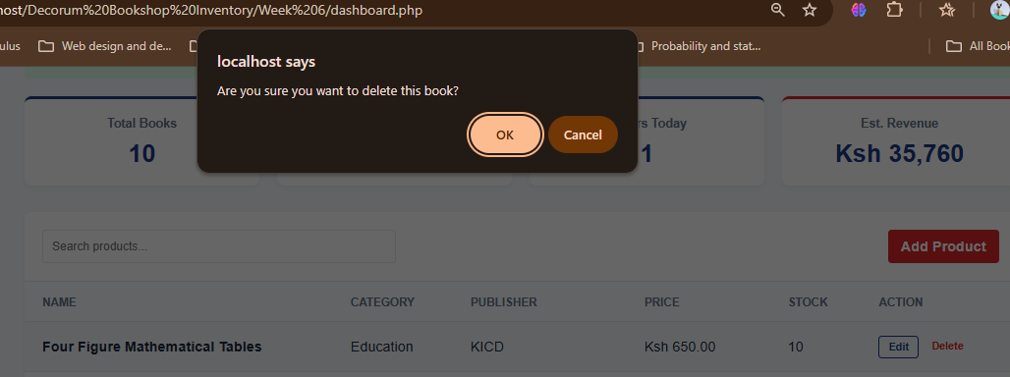
Figure 0-7:Delete Button flash message

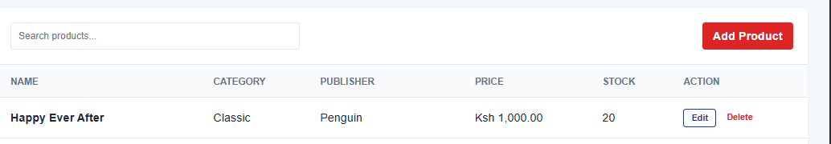
Figure 0-8;Deleted record(Four Figure Mathematical Tables)

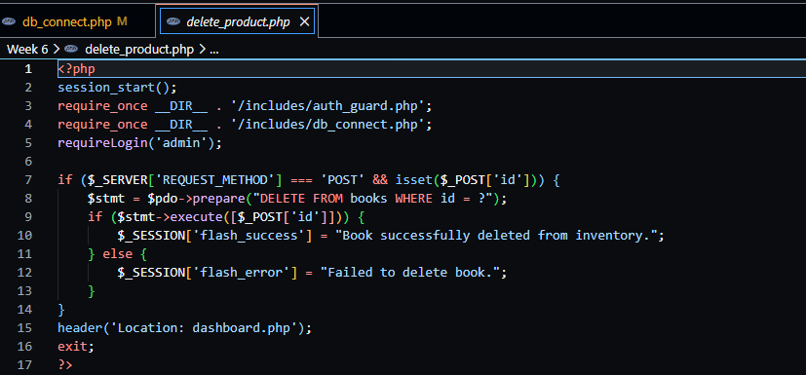
Figure 0-9:Delete_product script
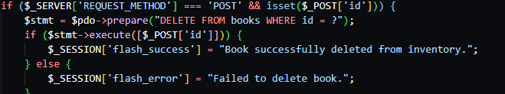
Figure 0-10; delete book prepared statements

REFLECTION
Figure 0-2 showsModularization- Seperated the database connection into its own dedicated file creating a Module that is pulled into the other pages(File Inclusion) using the require_once__DIR__ method. Figure 0-10 shows Use of prepared statement ($stmt = $pdo->prepare("DELETE FROM books WHERE id = ?") that provides a place holder for the book data . The if ($stmt->execute([$_POST['id']])….line binds the prepared statement to the actual book details and executes it sing METHOD=POST. This tells the databse to delete the record.

WEEK 7

User Authentication and Session Management

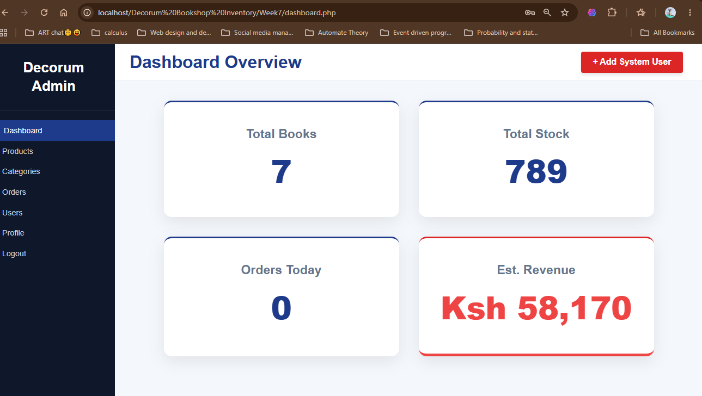
Figure 0-1:Admin Role View(Role Based Login)
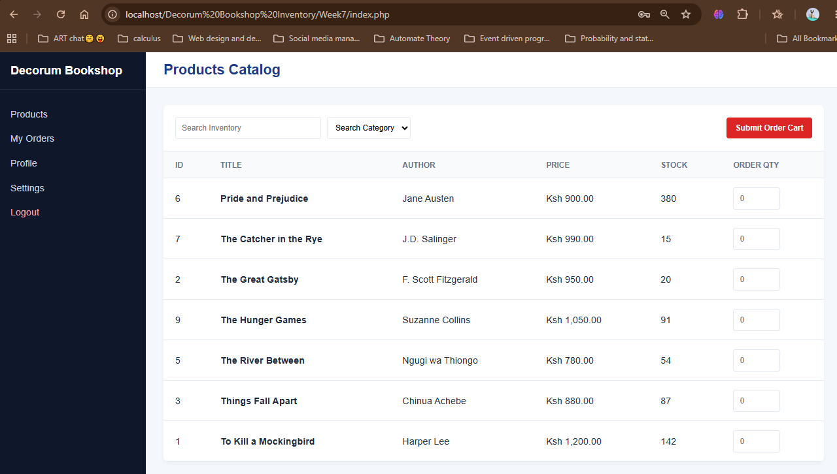
Figure 0-2; Manager role view
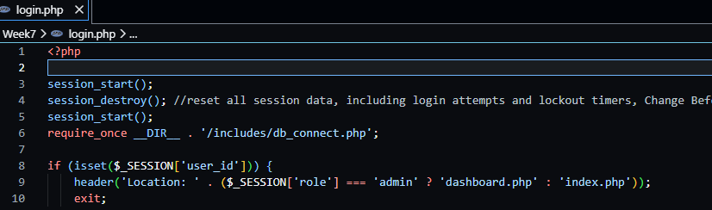
Figure 0-3:Script that directs user to dashboard or index according to Role

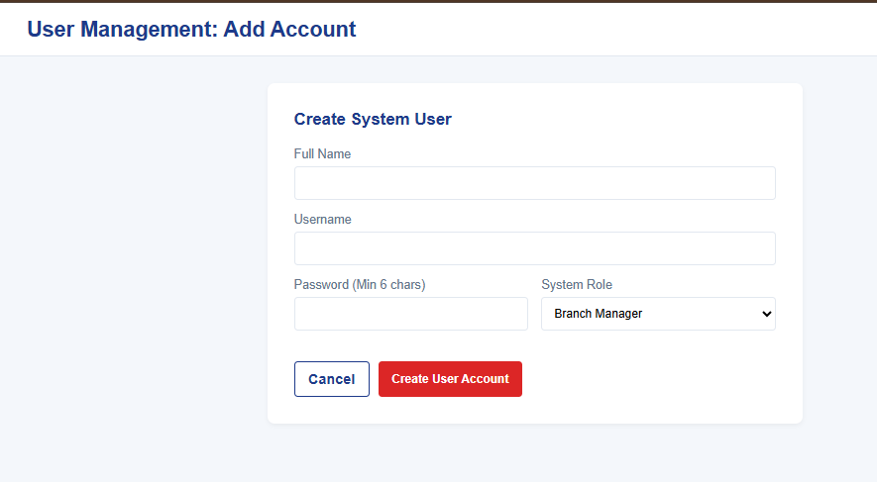
Figure 0-1:add new users form
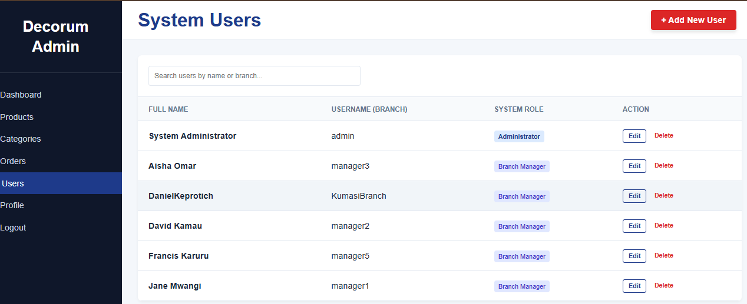
Figure 0-2;Secure User Registration Module. In this B2B architecture, public registration is disabled; users are securely provisioned by the Administrator to ensure system integrity.
Figure 0-1: Cryptographic Password Hashing. Proof of PHP's native password_hash() implementation. Passwords are never stored in plain text, mitigating the risk of database breaches.
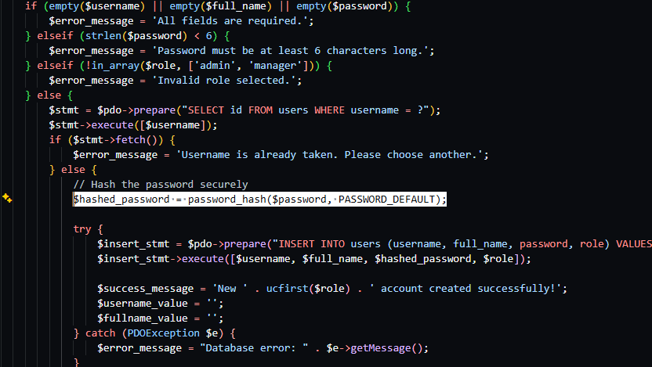
Figure 0-2; register_user_form.php file - script of the password_hash implementation

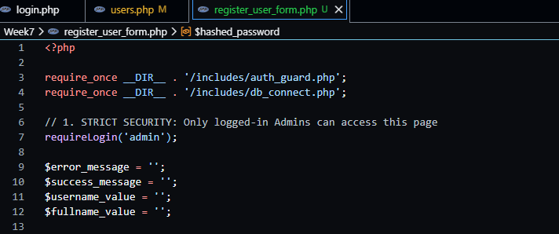
Figure 0-3; requireLogin('')Restricts acces of register_users_form.php to only Admins

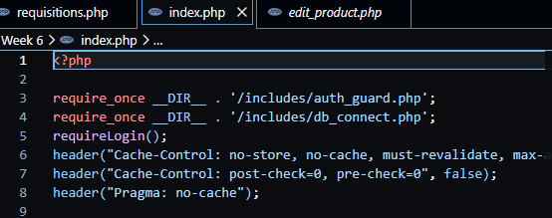
Figure 0-1:The Header (Cache-Control), is HTTP that instructs the browser not to Cache the page. To always validate the page, every time a user log in

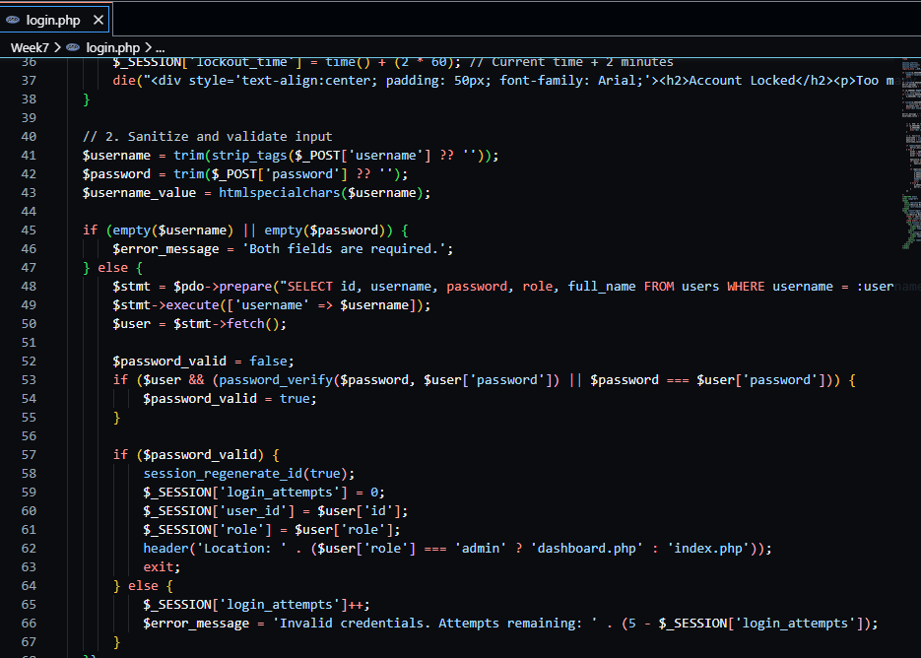
Figure 0-2;Backend logic demonstrating the initialization of secure session variables upon successful cryptographic password verification.
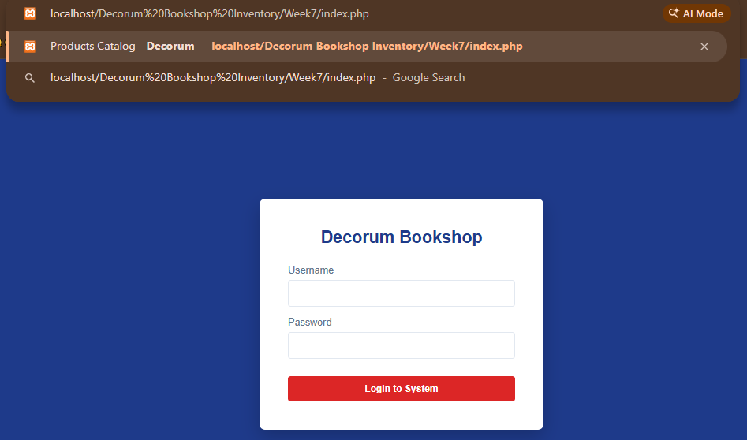
Figure 0-3;Session Management and Route Protection. Unauthenticated users attempting to bypass the login screen are intercepted by auth_guard.php and redirected, proving active session validation.
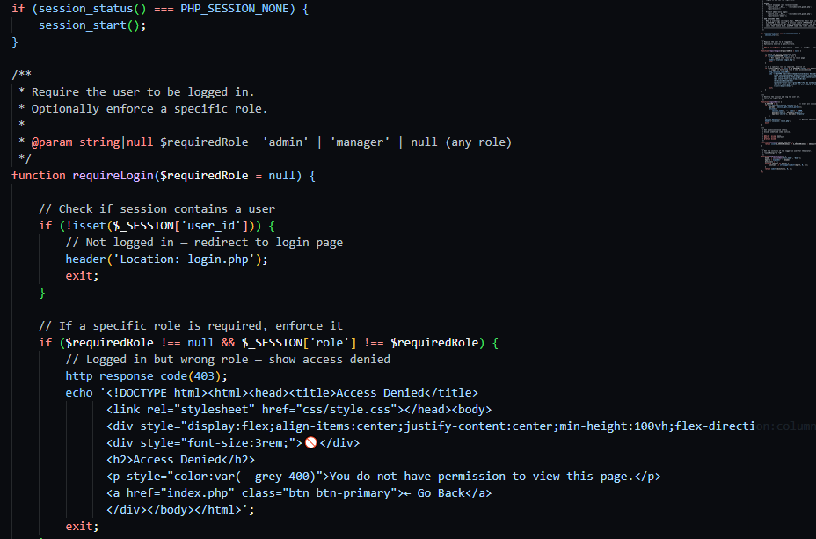
Figure 0-4:auth_guard.php- Session Management and Routing

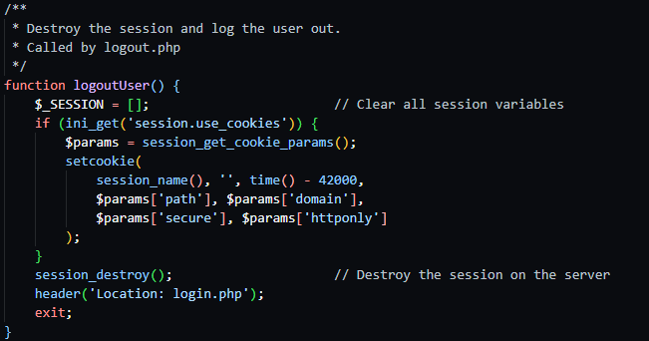
Figure 0-5:auth_guard.php - Destroy session and log out user script when logout button is clicked
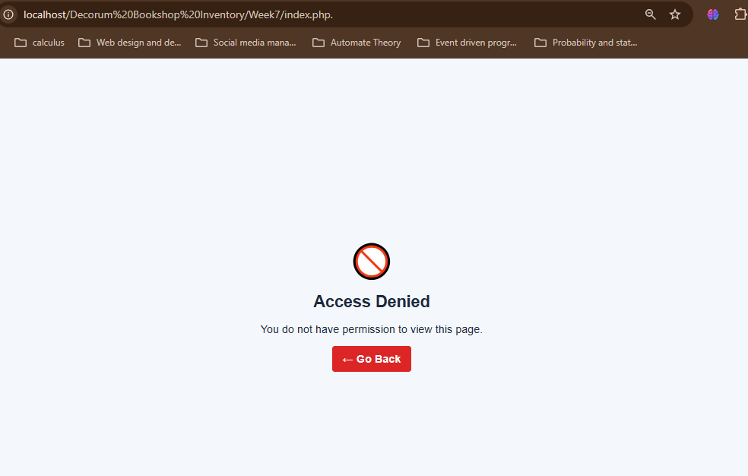
Figure 0-6: Acess to index.php denied with an Admin Role session without going through login page.Script in Figre0-4, (//logged in, wrong Role )

REFLECTION
By implementing PHP session management and Role-Based Access Control (RBAC), I successfully isolated the Administrator and Branch Manager workflows. The most significant learning was integrating cryptographic security using native password hashing to defend against database breaches, ensuring no plain-text credentials are ever stored. Transitioning the registration system into an admin-only provisioning tool further reinforced real-world B2B security practices including Rule Of Thumb for CRUD, providing a solid foundation in secure backend architecture.

WEEK 8

Responsive Web Design and Mobile-First Development

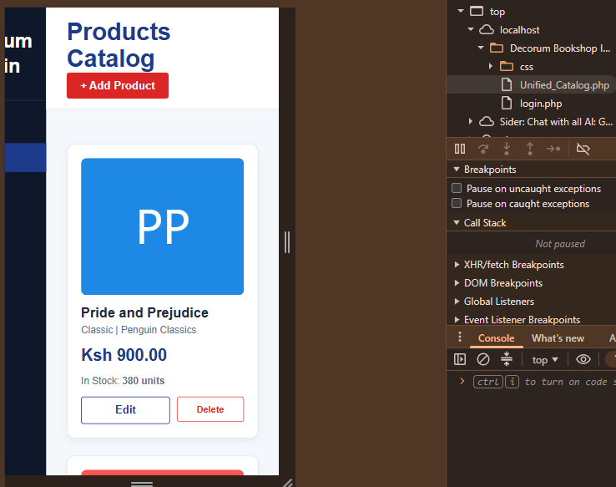
Figure 0-1:Book Stacked in Mobile view instead of table
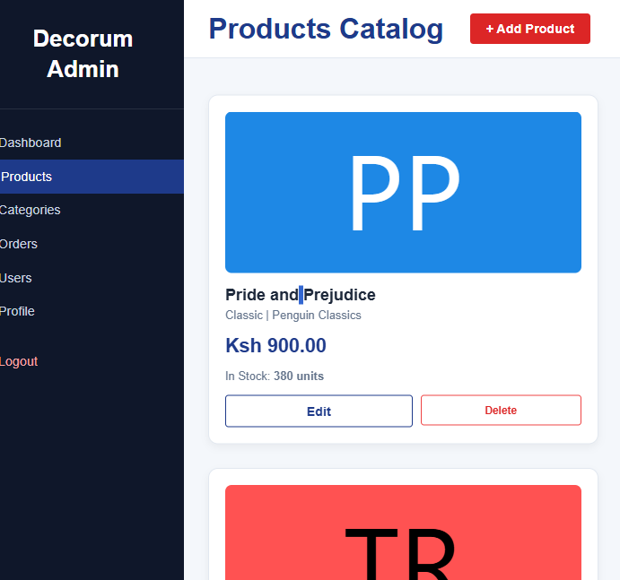
Figure 0-2; Product catalog web view

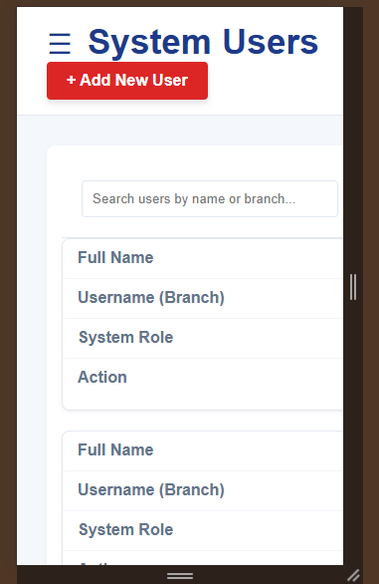
Figure 0-3; Hidden Sidebar(Users Mobile View)
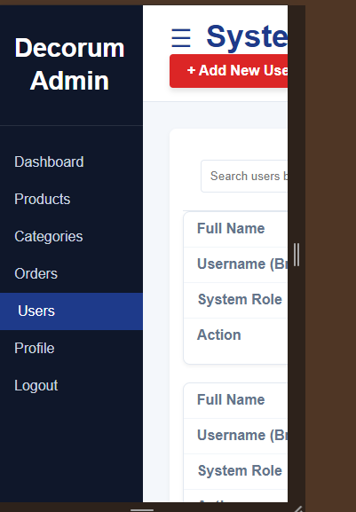
Figure 0-4; Exposed sidebar, System Users Mobile View
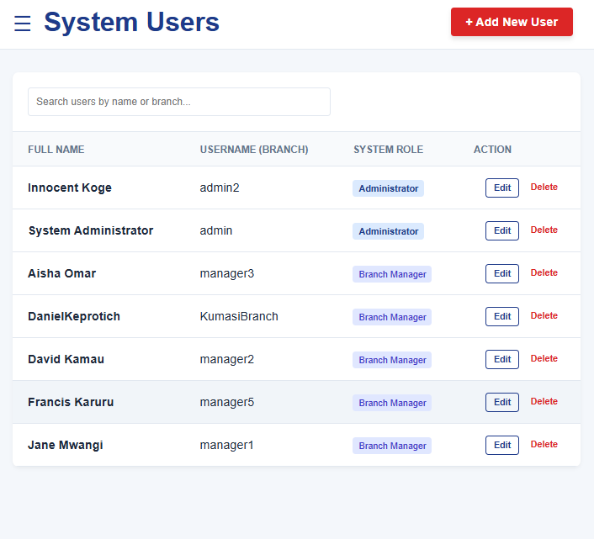
Figure 0-5: System User Webpage view

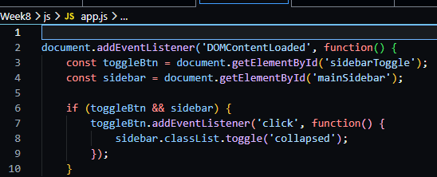
Figure 0-6; Sidebar toggle js script
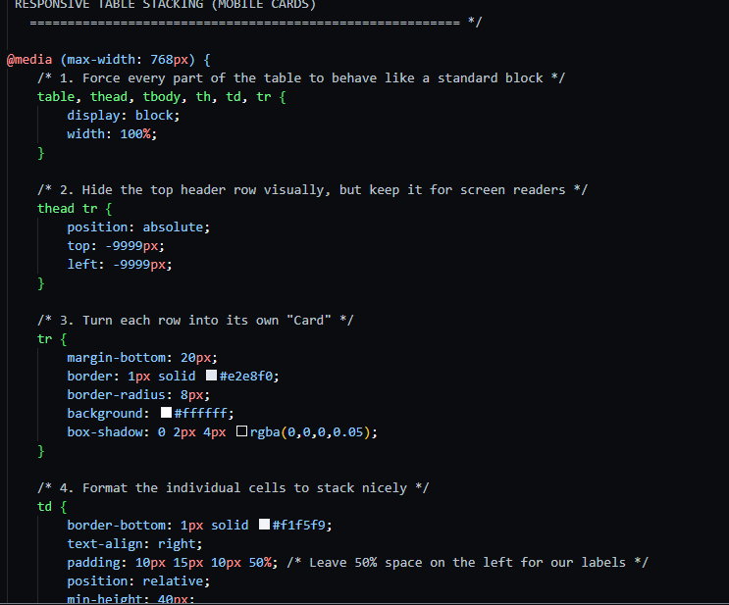
Figure 0-7; CSS Stylingthat makes a table act lie a stand alone block
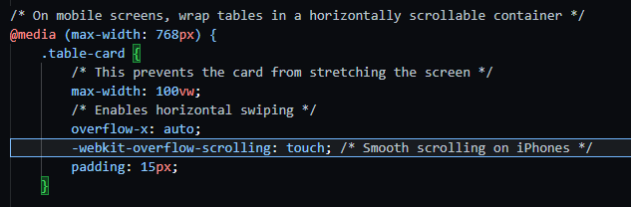
Figure 0-8: CSS Media Query that wraps tables in a horizontally scrollable container

REFLECTION
Learned how websites adapt to phone screens using Responsive Web Design. By adding the Viewport Meta Tag, I stopped mobile browsers from zooming out awkwardly. Used CSS Media Queries (@media (max-width: 768px)) and CSS Grid to completely transform our rigid data tables into beautiful, stackable mobile cards. Added app.js file that contains (addEventListener('click')) to create a functional "hamburger" sidebar toggle. Changing the table styling(CSS) proved to be a challenge.

